**Difference of Device**

1. **Hub vs Switch**

|  |  |  |
| --- | --- | --- |
| **Feature** | **Hub** | **Switch** |
| Data Transmission | Broadcasts data to all connected devices, regardless of the destination. | Sends data only to the specific device it is intended for, using MAC addresses. |
| Speed | Slower, usually **10 Mbps or 100 Mbps**. | Faster, supports **10/100/1000 Mbps** (Gigabit Ethernet Cable). |
| Intelligence | Dumb device no knowledge of network structure. | Smart device learns MAC addresses and builds a table. |
| Cost | Cheaper. | Slightly more expensive but more cost-effective long-term. |
| Use Case | Legacy or small home networks | Modern LANs, offices, and data centres. |

1. **Switch vs Router**

|  |  |  |
| --- | --- | --- |
| **Feature** | **Switch** | **Router** |
| Feature | Connects devices within the same network (LAN) | Connects multiple networks together (e.g., LAN to Internet) |
| Network Layer | |  | | --- | | Works at Data Link Layer (Layer 2) |  |  | | --- | |  | | |  | | --- | | Works at Network Layer (Layer 3) |  |  | | --- | |  | |
| Speed | High-speed data transfer within local network | |  | | --- | | Slightly slower due to routing tasks |  |  | | --- | |  | |
| Ip Assignment | Does not assign IP address | |  | | --- | | Can assign IPs via DHCP |  |  | | --- | |  | |
| Use Case | LANs, office networks | Internet access, connecting LANs |

1. **Router vs Gateway**

|  |  |  |
| --- | --- | --- |
| **Feature** | **Router** | **Gateway** |
| Function | Routes data between similar networks (e.g., LAN to WAN) | Connects and translates data between different network systems |
| Network Layer | Operates mainly at Layer 3 | Can operate at all layers |
| Complexity | Simpler, focused on IP routing | More complex. |
| |  | | --- | | Use Case |  |  | | --- | |  | | |  | | --- | | Home/office networks, internet access |  |  | | --- | |  | | Enterprise systems, different architectures (e.g., IoT to cloud) |
| Example | |  | | --- | | Home Wi-Fi router |  |  | | --- | |  | | VoIP gateway, email gateway, cloud API gateway |

**Working of Device**

1. **Switch**

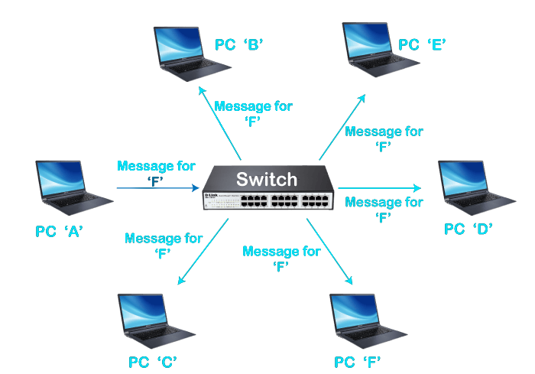

* Switches are used to connect devices within the same network or local area network (LAN). If you need to connect devices from different networks, you would typically use a router or a layer 3 switch, which can route traffic between different networks

1. **Router**

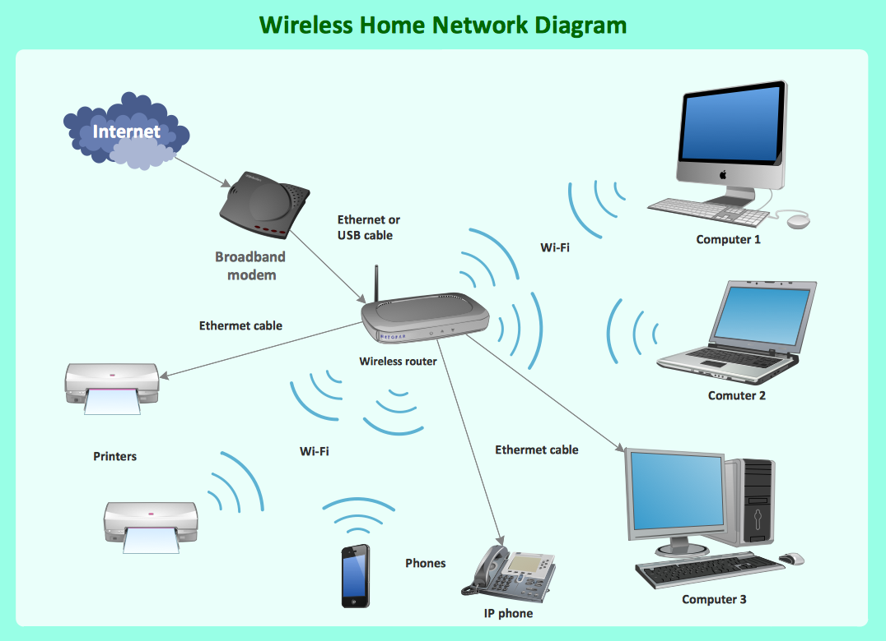

* Routers connect computers and other devices to the Internet. A router acts as a dispatcher, choosing the best route for your information to travel. It connects your business to the world, protects information from security threats, and can even decide which computers get priority over others.

1. **Gateway**

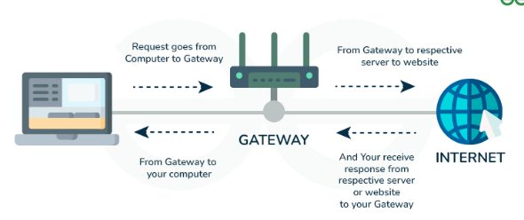

* The gateway receives data from devices within the network. After receiving data, the gateway intercept and analyse data packets, which include analysing packet header, payload etc